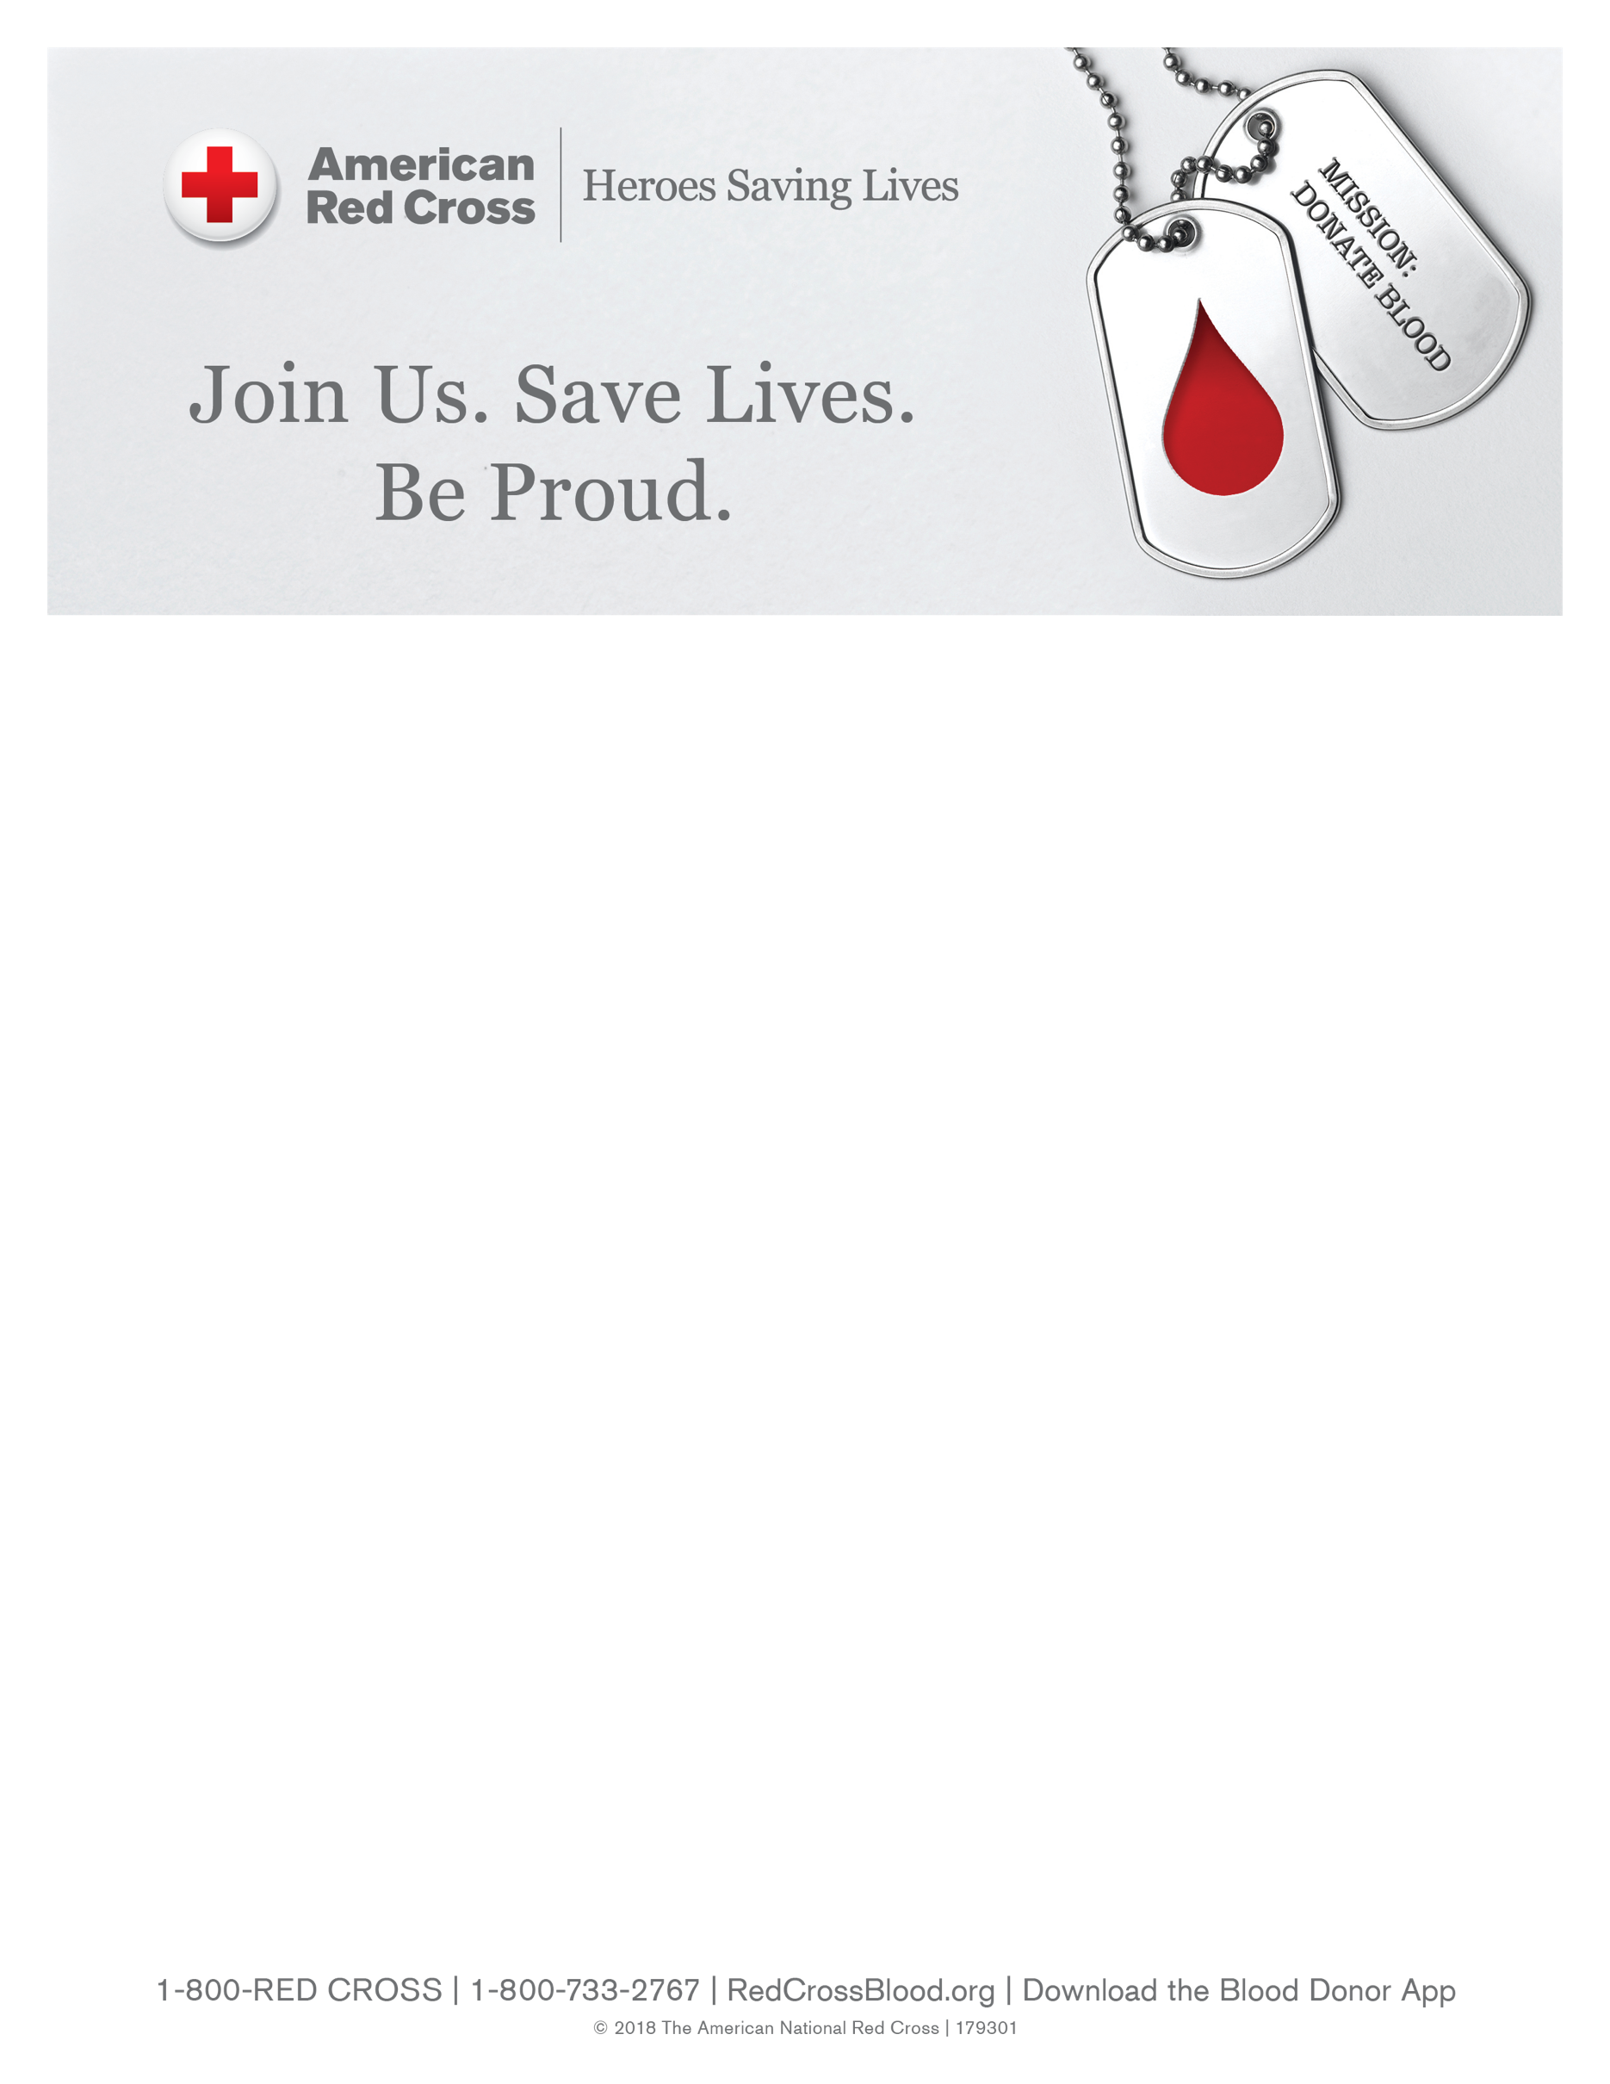

**Civil Air Patrol/VFW Blood Drive**

**Saturday, October 14, 2023**

**9:00-2:00**

VFW Atterbury Post

649 Churchmans Road, Newark, DE 19702

For an appointment, please visit https://www.redcrossblood.org/give.html/drive-results?zipSponsor=AtterburyVFW

Or call 1-800-RED CROSS (1-800-733-2767).

Here is the link to sign up and a form you should be able to print. We should be getting more marketing materials sent directly to you. Let me know if there's anything else I can provide to help.

<https://www.redcrossblood.org/give.html/drive-results?zipSponsor=AtterburyVFW>